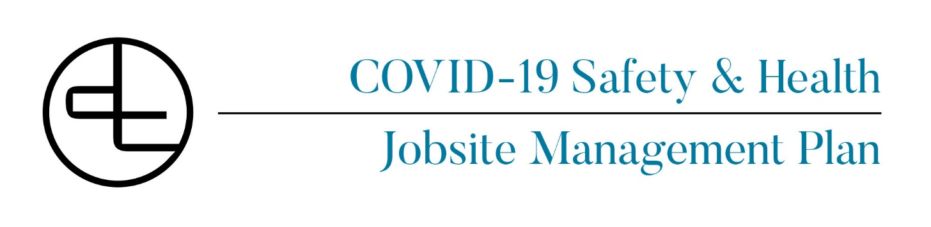

Project Name: Click or tap here to enter text.
Project Number: Click or tap here to enter text.
Project Address: Click or tap here to enter text.
Corporate COVID Officer: Tom McCollum
Last Updated: 6/30/20

www.dickinsoncameron.com California | New York

Contents
DCC COVID-19 Response Plan 3
Plan Purpose 3
Coronavirus (COVID-19) 3
Self-Awareness 3
DCC Job Entry Questionnaire: 3
Hygiene 6
Mitigation Plan 7
Cleaning and Disinfecting Protocols 8
Personal Protective Equipment (Standard Requirements Apply) 9
Working inside the 6’ social distance separation 9
Site Safety Requirements 10
Social Distancing 10
Communications 11
Emergency Procedures 13
Definitions 14
Project Specific Information 16
Raken Safety Survey Addendum 18
Sample Exposure Memo 19
Sample Checklist for Competent Persons Completing Close Proximity JHA 20
Sample COVID-19 Toolbox Talk 21
Required Site Signage (Covid-19) 22
Dickinson Cameron COVID-19 Best Practices for Jobsites: 27
Dickinson Cameron COVID-19 Jobsite Return to Work Protocol: 28

DCC COVID-19 Response Plan

Dickinson Cameron takes as the greatest importance the health and safety of our employees, subcontractors, workers & clients. With the spread of the Novel Coronavirus, COVID-19 we must remain vigilant in mitigating the outbreak, and specifically within the construction industry. As the safety of our people and jobsites are a top priority, we are closely following the CDC for guidance. We have gathered information from the CDC, World Health Organization, and OSHA and our industry peers to create this response plan and associated forms below and attached. This form has been updated several times, and we will continue update it, as we learn more about the spread and infection of this virus. The latest version has been updated as of 6/30/2020.

To learn more about the coronavirus, please visit the CDC website. https://www.cdc.gov/coronavirus/2019-ncov/index.html

Plan Purpose
• To establish health and safety protocols to support our construction projects during the COVID-19 pandemic. This plan is intended to be used as a tool for consideration and implementation. Every project will participate in preparing, implementing and adjusting as necessary a project specific plan taking into consideration the site-specific elements of that project.

Coronavirus (COVID-19)
• Coronaviruses are a type of virus. There are many different kinds, and some cause disease. A newly identified type has caused an outbreak of respiratory illness now called COVID-19.

Self-Awareness
- Any individual who is feeling sick or who is presenting any symptoms of a cold, flu, or COVID-19, is to stay home and/or seek medical attention. We must enforce a 100% zero tolerance policy which does not allow for anyone showing symptoms to be on the jobsite.
- All workers shall travel separately to the work site, when possible.
- Self-reporting paperwork.
- Upon arrival to the site, all workers must complete the self-reporting questionnaire with their foremen during their daily pre-task plan meeting. The questionnaire may be either in a written form or via a QR code individual survey to be filled out.
- Symptoms may include, but are not limited to:
      - Cough
      - Fever
      - Shortness of breath
      - Sore throat
      - Loss of smell or taste
      - Body aches
      - Other flu-like symptoms, such as chills, fatigue, muscle pains, headache, diarrhea, nausea/ vomiting, or running nose.

DCC Job Entry Questionnaire:
Every worker prior to entry to the DCC project site will access the QR portal and take a survey and submit it or verbally answer the posted survey questions in front of the site superintendent.

This is a sample view of the DCC QR portal:
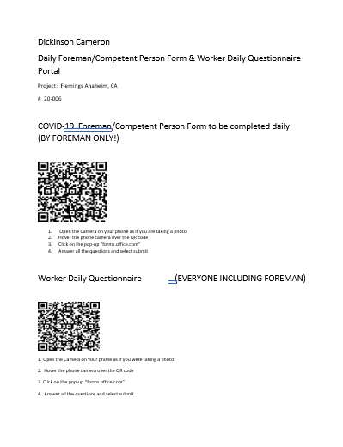

This is an example of the Jobsite entry Questionnaire via the QR portal:
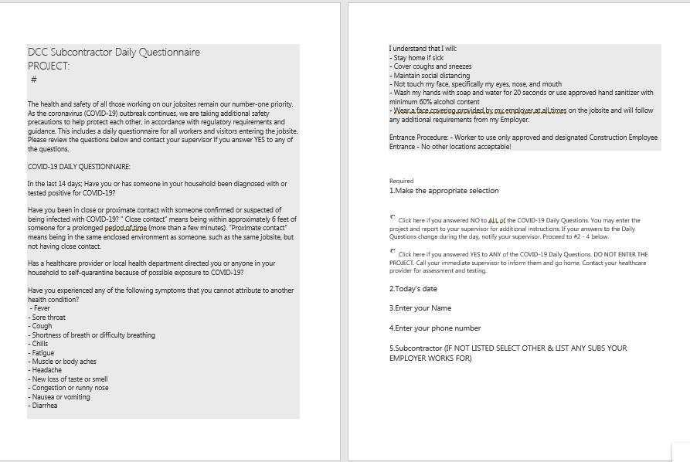

Hygiene
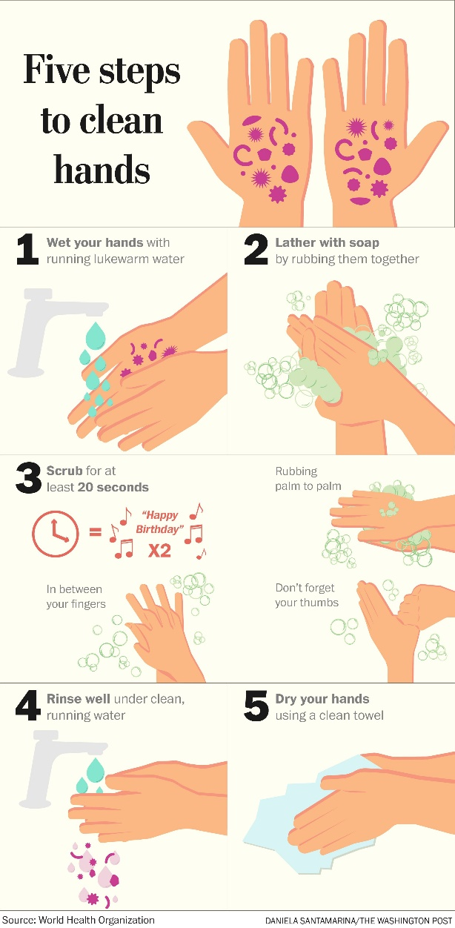
- Hand washing station requirements
- All DCC projects must provide access to hand washing, or hand sanitization stations.
- Plumbed sinks, both permanent or temporary, should be the first choice if possible.
- All hand washing stations must be spread apart to maintain social distancing.
- Note: each unit at least 6’ apart. Multiple person foot pump stations will have only one service sink available for use. One user at a time.
- Wash your hands often throughout the day, including:
- Before eating food
- After using the toilet
- After blowing your nose, coughing, or sneezing
- After touching garbage, or waste containers.
- Hand washing procedures—follow these five steps every time:
- Wet your hands with clean, running water (warm or cold), turn off the tap, and apply soap.
- Lather your hands by rubbing them together with the soap. Lather the backs of your hands, between your fingers, and under your nails.
- Scrub your hands for at least 20 seconds. Need a timer? Hum the “Happy Birthday” song from beginning to end twice.
- Rinse your hands well under clean, running water.
- Dry your hands using a clean towel or air dry them.
- Hand sanitizers
- Washing hands with soap and water is the best way to get rid of germs in most situations. If soap and water are not readily available, you can use an alcohol-based hand sanitizer that contains at least 60% alcohol. You can tell if the sanitizer contains at least 60% alcohol by looking at the product label.
Note: If a transfer bottle is used the master label will be made available.
- Provide single-use paper towels and trash bins, and place at all hand washing stations.
- Trash bins must be made available in the following areas:
  - Near jobsite office workstations
  - Outside restroom facilities
  - Near access doors
  - Any other location deemed necessary
- No common water sources – bottles only
- No food trucks – everyone must bring in their own food
- Other prevention measures:
- Do not shake hands when greeting anyone
- Avoid touching your face, eyes, nose, and mouth
- Do not share items unless they have been cleaned and disinfected
- Encourage change of clothes on site and at home as best practices
- To avoid passing germs, please clean up after yourself.
Note: Do not make others responsible for your personal belongings
- Cover your nose and mouth with your elbow when you cough, or sneeze cover your mouth and nose with a tissue when you cough/sneeze and throw the tissue in the trash and wash your hands after.
- Endeavor to eliminate carpooling where feasible to access the project sites.

Mitigation Plan
- Screening and Testing
- The following screening and testing guidelines and procedures shall be implemented on all projects as a condition for anyone to enter the site. A consistent, dedicated area for this to be done is required on each project, where this process can take place without risk of allowing an infected person to expose a large portion of the work area or other workers.
- Screening
- Prior to starting a shift, each employee will self-certify via a QR code survey or printed questionnaire that they:
- Do not have a positive diagnosis of COVID-19,
- Have no signs of a fever or a measured temperature above 100.0 degrees or greater, a cough or trouble breathing, sore throat or gastrointestinal symptoms within the past 24 hours,
- Have not had "close contact" with an individual diagnosed with COVID-19. “Close contact” is currently defined as:
  - Being within approximately 6 feet (approximately 2 to 3 seats on plane, train, bus) of a person confirmed to have COVID-19 for an extended period of time.
  - Close contact can occur while caring for, living with, visiting, or sharing a healthcare waiting area or room with a) a person confirmed to have COVID-19 or b) having direct contact with infectious secretions of a person conformed to have COVID-19 (i.e., being coughed on)
  - Any additional more stringent guidelines set forth by the specific project site policies and procedures.
- Have not been asked to self-isolate or quarantine by their doctor or a local public health official.
- Are not awaiting test results of a COVID-19 test
- If any worker does not fully pass this screening, they will be denied access to the jobsite.

- Testing Guidelines and Protocols
- Anyone entering the project site will be subject to temperature checking.
- People entering the site will scan the Project QR Code located outside the project limits which will take them to the project specific health screening survey, or read and self-survey from the posted questionnaire.
- Employees exhibiting symptoms or unable to self-certify will be directed to leave the work site and seek medical attention and applicable testing by their healthcare provider. They are not to return to the work site until:
      - They have not registered a temperature at or greater than 100.0 degrees Fahrenheit without taking medication to reduce their temperature for three (3) days.
      - There is an improvement in their respiratory symptoms (cough and shortness of breath).
      - At least seven (7) days have passed since their symptoms began.
This process will be repeated daily.

Cleaning and Disinfecting Protocols
- This guide was created off CDCs guidelines found here: https://www.cdc.gov/coronavirus/2019-ncov/community/cleaning-disinfecting-decision-tool.html
- Anyone involved in cleanup operations shall be trained in these procedures as well as be responsible for following OSHA’s Hazard Communication standard 29 CFR 1910.1200 https://www.osha.gov/laws-regs/regulations/standardnumber/1910/1910.1200, and OSHA’s standards on Bloodborne Pathogens 29 CFR 1910.1030 https://www.osha.gov/laws-regs/regulations/standardnumber/1910/1910.1030
- Each project shall have a project specific plan for cleaning and disinfecting. The plan will include criteria for cleaning the general areas of the site as well as project specific tasks.
Some of the key elements will include but not be limited to the following:
- Disinfecting of all shared equipment and tools will be required and the responsibility of each subcontractor.
- Establish formal procedure and responsibility to accomplish this i.e., cleaning at the beginning and end of each day.
- Assign dedicated labor for performing the above tasks. Increase cleaning services (cleaning frequency and type of cleaning in site “offices”, bathrooms and eating areas using alcohol-based cleaners.
- When entering a machine or vehicle which you are not sure you were the last person to enter, make sure that you spray/ wipe down the interior and door handles with disinfectant prior to entry.
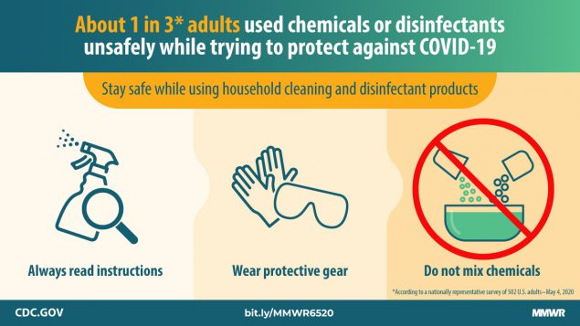
- Clean and disinfect frequently touched objects and surfaces and establish formal procedure and responsibility to accomplish and maintain these practices. Items such as all common areas, break/lunch areas, lunch tables, turnstiles, entry gates, handrails, microwaves, coffee machines, doorknobs, elevator call buttons, doorknobs, light switches, locks, gang box handles, ladder rungs, shared power tools, battery charging stations, restrooms, plan tables, chairs etc.

- Clean and disinfect frequently touched objects and surfaces
- The following cleaning and disinfecting protocol will serve as a guide for cleaning and disinfecting commonly touched surfaces, and shared areas. These areas include: elevator, ladder rungs, break/lunch areas, lunch tables, touch surfaces on microwave, coffee machine, refrigerators, and coffee machines; turnstiles, handrails, doorknobs, machine control surfaces (joysticks, controls, steering wheels), bathrooms, copy machines, and all common areas.
- Establish formal procedure and responsibility to accomplish and maintain these practices.
- As every site is different, the project Superintendent should map out and specifically identify the target areas for cleaning at the specific project.
- This cleaning and disinfection procedure is to be used for routine cleaning and disinfecting (this is NOT the protocol to follow when disinfecting for a known or suspected case of COVID-19). Cleaning and disinfecting should be performed on a regular basis for to maintain routine cleaning of the above-mentioned areas. In the event of a suspected or confirmed case of COVID-19, a third party environmental or specialty cleaning contractor should be used. The third party will determine the best work methods, protocol, and plan for the scope of work to be performed. For routine cleaning use the protocol outlined below.
- Cleaning and Disinfecting Materials
- Cleaning solutions:
      - Multi Surface Cleaning Products (examples: Purell or Clorox Multi Surface Spray, etc.)
      - Soap and water
- Disinfecting solutions:
      - Alcohol solutions with at least 60% alcohol
      - Bleach solution diluted with water
- Personal Protective Equipment (PPE) for cleaning:
- Nitrile gloves o face covering mask (minimum) o Safety glasses o Optional routine cleaning protective clothing: Tyvek type coveralls or gowns
- Following cleaning procedure, follow the below steps:
  - Remove all PPE, wash hands immediately with soap and water for at least 20 seconds.
  - Remove and dispose of gloves. Do not touch outside of gloves. o Remove face covering mask without touching outside or front.
  - Remove glasses and clean thoroughly with soap and water or alcohol-based wipe or cleaning solution. o Remove protective clothing without touching outside of garment and turn garment inside out before disposal.
  - Discard all non-reusable PPE in trash receptacle.

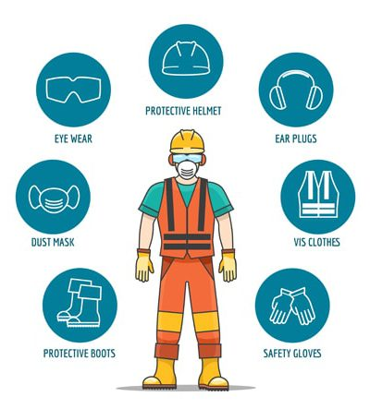
Personal Protective Equipment (Standard Requirements Apply)
- Hard hat
- Safety glasses
- Safety vest or shirt
- Boots
- Face Masks/ Covering (may be homemade)
- Gloves (as necessary)

Working inside the 6’ social distance separation
- For personnel working closer to each other than 6’ separating each worker (within 6’ in all directions), when both are healthy and showing no symptoms of illness/or are asymptomatic, the following shall be completed:
- Complete the step and risk mitigation on the subcontractors Job Hazard Analysis (JHA) detailing how to work safely within 6’.
- Obtain and use proper PPE, to include the minimum as follows:
  - Face shield
  - Safety glasses
  - Hard hat
  - Face covering/ mask
  - Do not share PPE.
- Multi-person tasks that cannot be performed while maintaining social distancing include, but are not limited to:
- Working in lifts or scaffolding
- Setting block or stone requiring tenders to supply materials.
- Confined space such as manhole/vault work with more than one person
- Excavation or trench work with activities in proximity
- Setting glazing—two workers in a boom lift
- Placing and finishing flatwork concrete (usually it’s a crew dragging the hose, spreading and finishing concrete all clustered up shoulder to shoulder)
- Mechanical trade installing HVAC ducting or kitchen hoods overhead—usually multiple workers holding large 12’ hoods up while installing
- Drywallers working in scissor lifts, or rolling scaffolds, installing sheetrock overhead—usually a pair to hold and screw in overhead work
- Unloading materials that require multiple people (drywall, doors, mechanical equipment)
Note – disinfect PPE before bringing in your personal vehicle or home.

Site Safety Requirements
- Our Superintendent is the COVID-19 officer and will be onsite 100% of the time to enforce all site safety rules
- Safety orientations are not to be completed in a group setting
- Limit visitors to the site—only essential personnel on site
- Keep high-traffic areas clean and clean frequently throughout the day
- All COMMON AREAS/MEETING AREAS/HIGH CONTACT AREAS SHALL BE DISINFECTED
- DAILY AS A MINIMUM FREQUENCY
- All personnel must take the daily pre-entry health screenings/ survey, to include:
- Do you have any of the following symptoms:
  - Difficulty breathing
  - Cough
  - Fever
  - Sore throat
  - Loss of smell/scent
  - Body aches
- Does anyone in your home have any of the above symptoms?
- Have you been in close contact with anyone that tested positive for COVID-19?
- Social Distancing must be established for all vertical transportation (elevators). These protocols shall be established for all projects and appropriate signage shall be in place. Using stairs shall be encouraged.
- Do not share any tools or devices without properly disinfecting them
- Site signage to include in English and Spanish:
  - COVID-19 information poster which should include signs and symptoms
  - Reminder posters to wash your hands

Social Distancing
- 6’ distance between you and other workers in all directions (200 sq. ft)
  - Minimizing crew size may be required
- Staggering shifts may be required
- If any task requires more than one person to complete, you must follow your updated JHA and wear additional PPE, such as:
- Face shield o Safety glasses o
- Hard hat o Face mask
- All meetings should be held outdoors or in open space (6’ distance)
- Personnel should be limited to essential personnel only
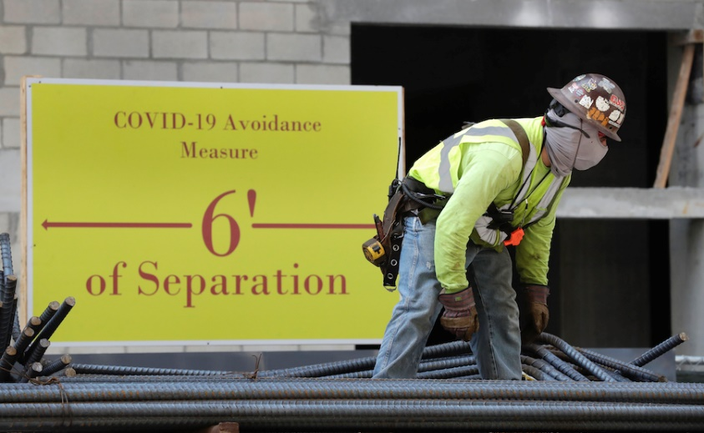

Communications
- Site Specific Safety Procedure
- It shall be required that all active construction projects have a safety meeting following the development of a site-specific COVID 19 plan. This safety meeting will introduce this plan and focus on the following key elements:
    - Review the guidelines and expectation set forth in this document
    - Review the role of what each contractor is doing to help prevent the spread of COVID-19
    - Inform employees of resources available to self-educate (web links)
    - Review locations of wash facilities on site
    - Review sanitation requirements
    - Add Covid-19 plan requirements to site orientation that all workers on site will be required to view or attend o This safety meeting shall comply with the 6’ social distancing. This may require this safety meeting to be administered in smaller groups or by each trade individually.
- Orientation
- It is required that all projects implement an orientation for each worker to review in general the requirements of this program. The orientation will be for all existing employees working on site as well as any new employees that arrive to work on site.
- The orientation shall review at a minimum:
  - The stay at home if you are sick requirements
  - The job check-in survey question requirements
  - Temperature screening procedures
  - Locations of wash facilities on site
  - Expectations to implement social distancing for all activities on site
  - Emergency response procedures

- Subcontractor Toolbox Talk
- It is the expectation that periodic toolbox talks be held as part of ongoing education and to provide updates to the workforce on the COVID-19 virus. Toolbox talks should also be held on proper personal hygiene and sanitation methods. It will be the responsibility of each subcontractor to provide and conduct this toolbox talk training for their workforce.
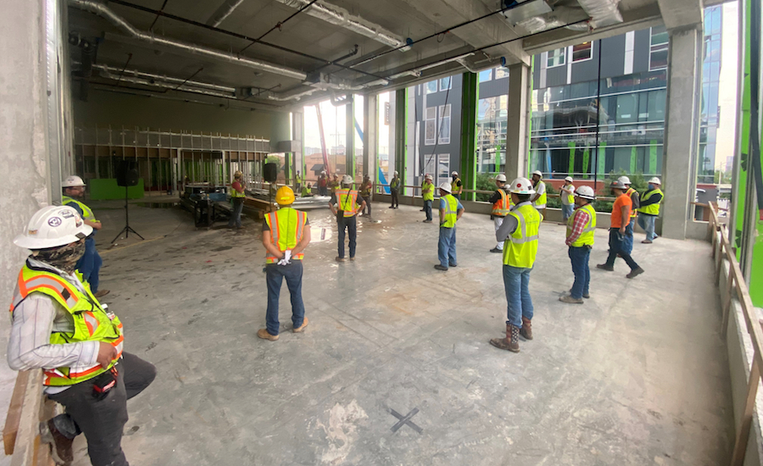

- Pre-Task Planning (JHA)
- All activities performed on site will have a component of the pre-task planning, noted in the Job Hazard Analysis (JHA), dedicated to performing the task in consideration with this plan and the CDC guidelines specific to social distancing.
- Pre-Task planning should include specific efforts towards minimizing exposure when crews must work closer than 6’. (Elevator hoist work)
- Signage
- Each project shall have signage posted to educate employees on COVID-19 safety guidelines throughout the project. Signage should be places in conspicuous areas.
- Link to CDC Posters:
https://www.cdc.gov/coronavirus/2019-ncov/communication/print-resources.html?Sort=Date%3A%3Adesc

Emergency Procedures
- In the event of a possible exposure to a COVID-19 person or someone that was in contact with a presumed positive COVID-19 person.
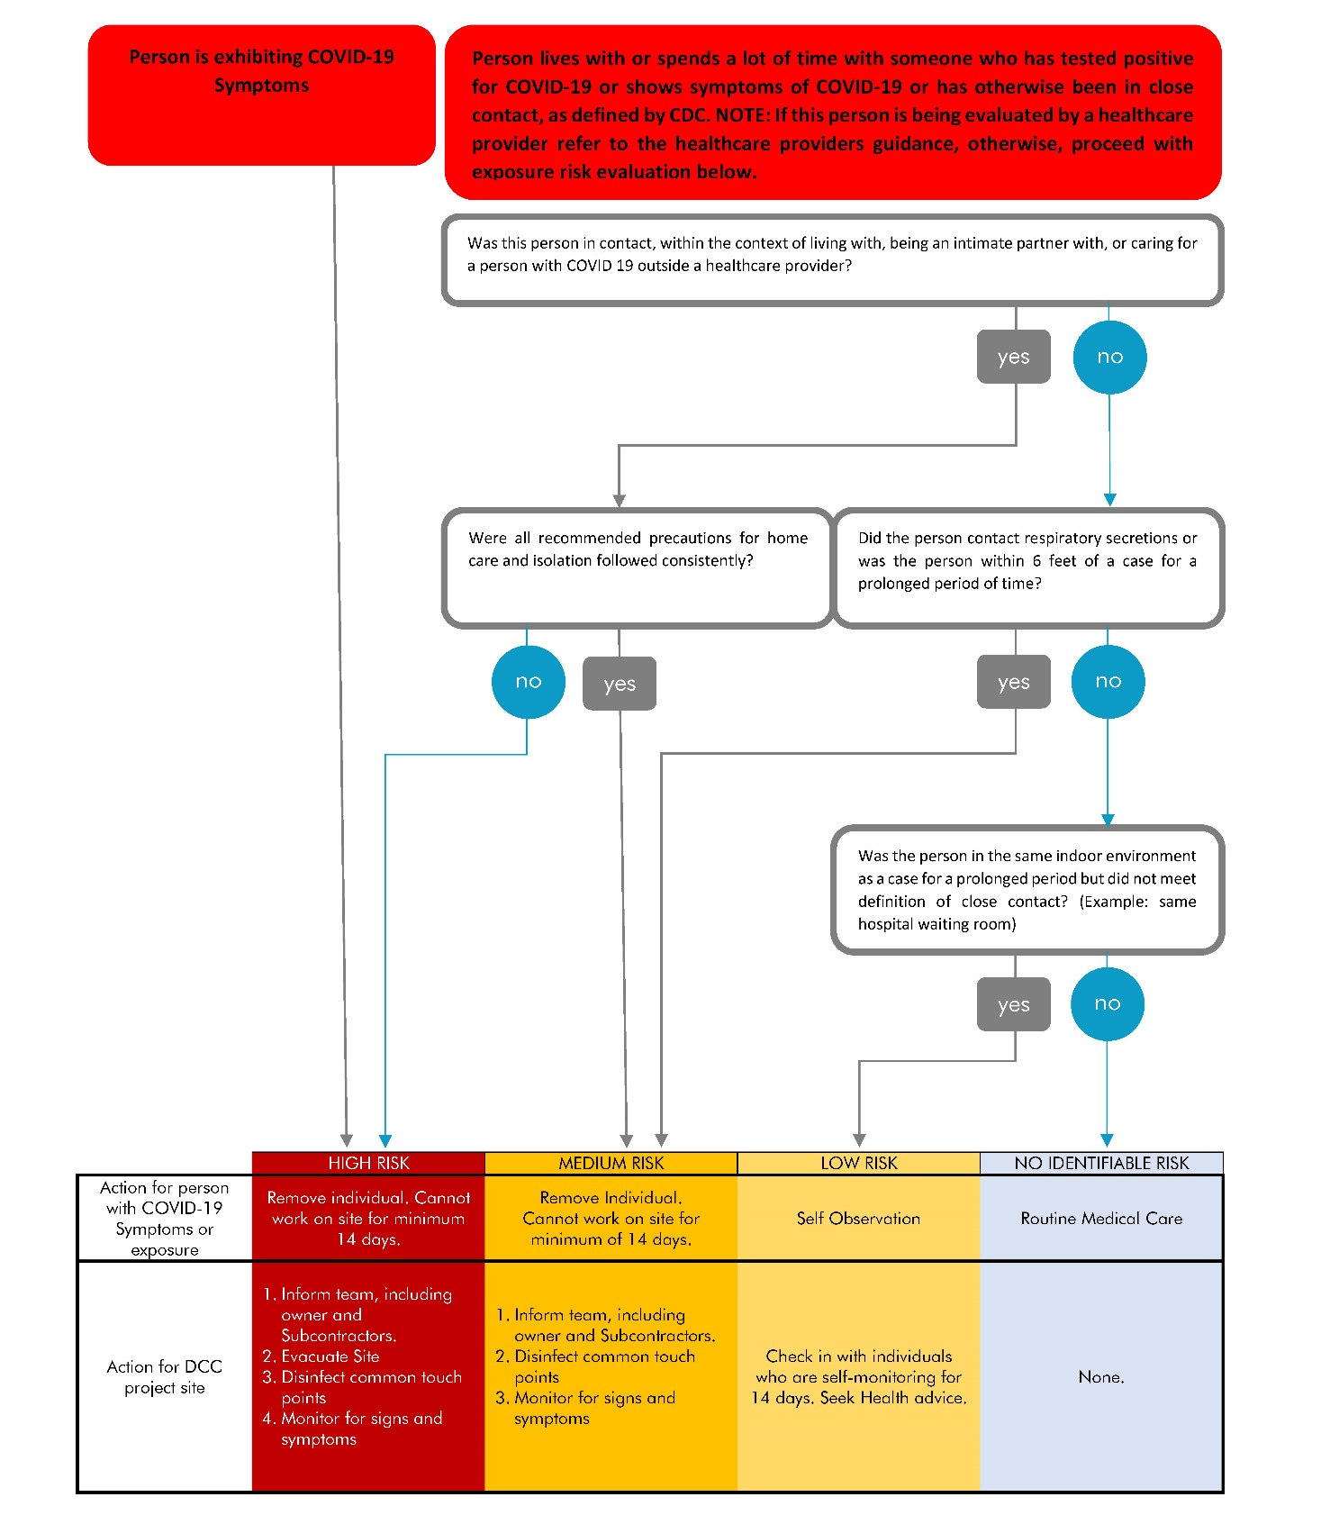
  - Follow the exposure decision flowchart (below) which is based off CDC guidelines.

  - The importance of reviewing the decision flowchart is that it covers scenarios we may experience, and it will continue to be updated as new information comes. This is a dynamic document that explains what to do in unique situations.
- Prompt identification and isolation of potentially infectious workers is a critical step in protecting other workers and building occupants on the jobsite.
- If a worker starts to exhibit symptoms during their shift, they shall leave the jobsite immediately and contact their healthcare provider. If they are unable to leave the work site, they will be placed in quarantine to isolate potential exposure to other workers. Potential infected worker will wear a face mask while leaving the jobsite or in quarantine.
- If worker is confirmed positive for COVID-19 we will make appropriate notifications to those who had direct prolonged contact with the COVID-19 positive worker.
- All other workers will evacuate the area of exposure and be sent home. The infected worker will have safe transportation arranged by his employer.
- The Contractor shall work with the local board of health to identify any potential jobsite exposures, including:
  - Other workers, vendors, inspectors, or visitors to the work site with close contact to the individual.
  - Work areas such as supply cabinets and designated workstations or rooms
  - Work tools and equipment
  - Common areas such as break rooms and tables, vending machines, and sanitary facilities
- As provided by law, the identity of the worker must be kept confidential.
- Upon learning of an infection, DCC must immediately notify the designated COVID-19 safety officer or Superintendent, Corporate Safety Officer, owner and subcontractors.
- Contractor shall take immediate steps to sanitize common areas and direct workplaces. This includes all on-site bathroom facilities, any break facilities, and any other common areas on the job site that may have been in close contact with the infected worker.
- Sanitation will be conducted with personnel, equipment, and material approved for COVID-19 sanitization.
- Identified areas should remain isolated from workers until sanitation process has been completed and area is deemed safe for use.
- All impacted workers should follow CDC, DPH, and local jurisdiction recommended steps concerning return to work. Workers who are considered close contacts to a COVID-19 case by public health authorities should not return for 14 days and are subject quarantine by public health.
- Workers who leave during the workday due to COVID-19 symptoms and develop COVID19 as confirmed by laboratory testing or diagnosis by a healthcare provider shall not return to the site until either released from isolation by healthcare provider or public health.
- In All Cases
  - Keep all employee names confidential as required by law.
  - Other employees may be sent home while a workspace is being cleaned but will return to work after cleaning unless advised otherwise by a health care provider.
  - Other employees should be asked to contact their health provider if they have any questions. Remind other employees to continue to practice proper sanitation and monitor for flu like symptoms.

Definitions
- Close contact:
  - Being within approximately 6’ of a COVID-19 case for a prolonged period; close contact can occur while working with, caring for, living with, visiting, or sharing a healthcare waiting area or room with a COVID-19 case
  - Having direct contact with infectious secretions of a COVID-19 case (e.g., being coughed on)
- Symptoms, for the purpose of these recommendations:
  - Subjective or measured fever
  - Cough
  - Sore throat
  - Fatigue
  - Loss of smell or scent
  - Difficulty breathing

Project Specific Information

JOB #: Enter Job # Here
JOB NAME: Enter Job Name Here
JOBSITE STATUS: Active

JOBSITE COVID-19 HEALTH SAFETY & MANAGEMENT PLAN:

DCC Field team is checking through and ensuring the following items are completed and set in place throughout the day. All trades are to strictly adhere to DCC’s COVID Health & Safety Management plan. Any questions or concerns can be directly addressed to the site superintendent. Any failure to adhere to these new protocols & policies will result in the permanent removal of worker(s) from the jobsite.
- All workers are to report to the jobsite side entrance at: Enter Description Here, for a preliminary screening (QR code Survey and visual health inspection).
  - Enter text here will be reserved for material deliveries ONLY.
  - Arrival times will be staggered when necessary to maintain social distancing.
  - There will be no shared sign-in sheets at this time. Workers will still be responsible for carrying their certifications at all times.
- Daily health & safety documentation to be completed by sub’s foreman on a daily basis and submitted to DCC field staff.
o There will be zero tolerance for sick workers reporting to the project site. Any worker who is sick or has been exposed to a sick person will be asked to go home.
- All COVID signage and informative posters/flyers to be posted at the screening station within view of the site entrance. Additional signage will be posted throughout the jobsite.
- All workers are to practice the most updated requirements of PPE including hard hats, safety glasses, plastic/rubber gloves (as necessary), masks, face shields, etc. (mouth, & nose to be covered at all times).
- All workers are to practice social distancing with a minimum of 6’ distance apart from one another (DCC field staff to strictly enforce this protocol wherever possible).
- For work that is “COVID-19 high risk” because social distancing cannot be maintained, trade forepersons will need to fill out a JHA with the DCC COVID Officer prior to performing the work.
- All trades are to perform their weekly toolbox talks. Daily safety reviews are to be filled out daily taking into consideration with CDC guidelines specific to social distancing. All foreman should host meetings in open areas. Weekly foreman meetings with DCC will be shortened and held outside the jobsite whenever possible.
- All COMMON AREAS/MEETING AREAS/HIGH CONTACT AREAS SHALL BE DISINFECTED
TWICE PER DAY
- *Note – disinfect PPE before bringing in your personal vehicle or home.
- DCC will implement cleaning measures including but not limited to the following:
EXAMPLE:
- There are 2 handwashing stations, on the 1st floor near the temp toilets and in the cellar near the stair tower, that are to be refilled daily with water, antibacterial soap, & disposable handwash towels.
- Hand sanitizer stations to be available:
    - In the cellar near the field office,
    - On the cellar mezzanine near the existing stair, • On the 1st floor near the existing feature stairs
    - And on the 2nd floor near the stair tower.
    - The following areas to be disinfected twice daily:
      - Side Entrance (Doors, Hardware, Tables, Chairs, Etc.)
      - Field Office (Doors, Hardware, Tables, Chairs, Etc.)
      - Temp Toilets
      - Hand Washing Stations
      - Hand Sanitizer Stations
      - All Railings
- The following cleaning and disinfecting protocol will serve as a guide for trades for cleaning and disinfecting commonly touched surfaces and shared areas. Establish formal procedure and responsibility to accomplish and maintain these practices.
- These areas include but are not limited to break/lunch areas, touch surfaces on microwave, coffee machine, refrigerators, doorknobs, gang boxes, ladders, tools, lifts, joysticks, controls, steering wheels, etc.
- Equipment operators will be directed to disinfect interior surfaces of all shared equipment before/after use.
- Workers will be encouraged to bring their own food to the jobsite to minimize exposure.
- Work breaks are to be conducted in large open spaces. Break times can be staggered if required to maintain proper social distancing.
- Small spaces and use of these areas should be staggered to avoid crowding.
- This cleaning and disinfection procedure is to be used for routine cleaning and disinfecting (this is NOT the protocol to follow when disinfecting for a known or suspected case of COVID-19).
- Cleaning and disinfecting should be performed on a regular basis for to maintain routine cleaning of the above-mentioned areas.
- In the event of a suspected or confirmed case of COVID-19, a third party environmental or specialty cleaning contractor should be used. The third party will determine the best work methods, protocol, and plan for the scope of work to be performed. For routine cleaning use the protocol outlined below.
- Cleaning and Disinfecting Materials § Cleaning solutions:
- Multi Surface Cleaning Products (examples: Purell or Clorox Multi Surface Spray, etc.)
- Soap and water
- Disinfecting solutions:
- Alcohol solutions with at least 60% alcohol
- Bleach solution diluted with water
- Personal Protective Equipment (PPE) for cleaning:
  - Nitrile gloves (recommended)
  - KN95 mask or equivalent
  - Safety glasses
  - Optional routine cleaning protective clothing: Tyvek type coveralls or gowns
- Following cleaning procedure, follow the below steps:
  - Remove all PPE, wash hands immediately with soap and water for at least 20 seconds.
  - Remove and dispose of gloves. Do not touch outside of gloves.
  - Remove mask without touching outside or front.
  - Remove glasses and clean thoroughly with soap and water or alcohol-based wipe or cleaning solution.
  - Remove protective clothing without touching outside of garment and turn garment inside out before disposal.
  - Discard all non-reusable PPE in trash receptacle.
- Site Communication Protocol:
Upon identifying an individual that seems “other than of normal health” DCC field staff to verify that worker immediately exits the building along with any individuals that may have had close contact with this individual. A detailed report to be filed, communication with Project team, FOM, CSO, HR, Client & owner of subcontractor to be notified of sick/infected employee.
  - In the event of a possible exposure to a COVID-19 person or someone that was in contact with a presumed positive COVID-19 person, Follow DCC Flowchart (page 14) which was created based off CDC guidelines.
  - Superintendents to walk around and verify that the building is clear of any workers not adhering to protocols.

Raken Safety Survey Addendum

The following questions will be added to the Raken Daily Safety survey completed by each DCC Superintendent.

Yes No Comments
COVID-19 signage posted throughout site
Hand washing stations available and soap 6’ apart
Daily temperature readings
Social distancing is being practiced, including access areas
All staff bringing in their own food, no food trucks allowed
Elevators – for work within, JHA must be completed to mitigate risk for work inside social distance guideline
Close-proximity work (work within 6’) – requires a separate plan by Competent Person (JHA)
Commonly touched areas are disinfected daily
No large gatherings of >5 people unless in large area where social distancing occurs
No closed-space areas, such as break rooms, allowed
Meetings are held virtually when possible or in large rooms
Required PPE for all employees
No handshaking or exchange of materials (paper, pens, equipment)
Wipe down equipment before use, after another person
All Competent Persons has completed QR entry survey for Competent persons and Foreman

Sample Exposure Memo

To our valued project team members:

Today, we learned that someone on our jobsite [has tested positive/is exhibiting symptoms but has not yet been able to be tested] for COVID-19 (2019 novel coronavirus). This individual was last on the jobsite on [DATE]. Therefore, the last known potential contact for our team with this individual was [#] days ago. The individual works [describe the area/floor/ etc. where the individual works while keeping the individual’s identity private as best you are able]. We have reached out directly to those individuals whom we are aware of that were in “close contact” with the impacted person. This is defined by the CDC as “being within approximately six feet of a COVID-19 case for a prolonged period of time. (15 min.” We have instructed potentially impacted team members to self-quarantine at home, and consult a physician for verified testing.

As always, your safety is our top priority. We will sanitize all common touchpoint areas and have asked the individual to leave the site until their self-quarantine period is complete and they are healthy to return to work (minimum 14 days).

While most team members were not in close contact with the individual, we recommend that all team members take precautions outlined by the CDC—even if they were not exposed through close contact. These include:
- Monitor your health symptoms which include a fever (over 100.0°F), cough, and shortness of breath
- If symptoms develop, self-quarantine and call your healthcare provider
- Practice social distancing
- Wash your hands frequently and avoid touching your face

While we understand that this may cause concern for you, we want to assure you that we are taking every precaution possible and care about your health and the health of your families. Please do not hesitate to reach out to your manager or Dickinson Cameron’s Covid-19 Safety Manager. (Tom McCollum tom@dickinsoncameron.com) if you have any questions or if you develop symptoms and are tested for COVID-19.

Sample Checklist for Competent Persons Completing Close Proximity JHA

Close Proximity Work (Within 6’)
What task needs to be performed while working within 6’?
Has everyone involved in this task read the daily health screening? Are they healthy? This is a must.
Does everyone have the required PPE?
- Hard hat
- Safety glasses
- Face shield
- Face mask (N95 mask if available, homemade mask is acceptable if not such as a bandana)
- Gloves
All staff involved in close proximity work will follow strict hygiene procedures, to include proper hand washing as soon as operation is complete.

Sample COVID-19 Toolbox Talk

Coronaviruses (CoV) are a large family of viruses that cause illness ranging from the common cold to more severe diseases and this year we are now experiencing COVID-19. This has been affecting people all over the world and is of particular concern to older people (60+) and people with underlying health conditions. This is not to say that others can’t be affected by this, but statistics show the people in those groups are at the greatest risk.

Common signs of infection include respiratory symptoms, fever, cough, sore throat, loss of smell or sent, shortness of breath and breathing difficulties. In more severe cases, infection can cause pneumonia, severe acute respiratory syndrome, kidney failure and even death.

What we know so far is that infected people can spread COVID-19 through their respiratory secretions, especially coughs and sneezes. According to CDC, spread from person-to-person is most likely among close contacts (about 6 feet). This is thought to occur mainly via droplets produced when an infected person coughs or sneezes. These can land in the mouths or noses of, or can be inhaled by, those nearby. It is unknown if COVID-19 can be transmitted by a person touching a virus-laden surface and then touching their own mouth, nose, or possibly their eyes.

Standard recommendations to prevent infection spread include:

- Clean your hands
Washing your hands often will help protect you from germs. If soap and water are not available, use an alcohol-based hand rub. Please make sure and use the trash cans. If you see they are full or we are missing products, please notify us right away.
- Avoid close contact
Avoid close contact with other people. We want to maintain 6’ of distance from others at all times. If you must work in close proximity you must notify your supervisor and we will work on a plan together to make sure you have all the proper equipment.
Stay home when you are sick, we have implemented a Zero Tolerance for anyone that is sick. At all times, you must stay home from work when you are sick. This will help prevent spreading your illness to others.
- Cover your mouth and nose
Cover your mouth and nose with a tissue when coughing or sneezing; this may prevent those around you from getting sick. Flu and other serious respiratory illnesses are spread by cough, sneezing, or unclean hands.
- Avoid touching your eyes, nose or mouth
Germs are often spread when a person touches something that is contaminated with germs and then touches his or her eyes, nose, or mouth.
- Twice daily cleaning of commonly used / touched areas
We will ensure all commonly touched areas and surfaces are cleaned at least daily.
- Break areas
At no point should we ever see >10 people gathered together. All meetings and breaks are to be taken outside or in an open-air space.
- Daily health screening
Upon entering the site each day, you will use the QR portal to take the survey/ questionnaire that asks you a series of health-related questions. It is imperative and the success and health of everyone on this site depends on honesty.

Required Site Signage (Covid-19)
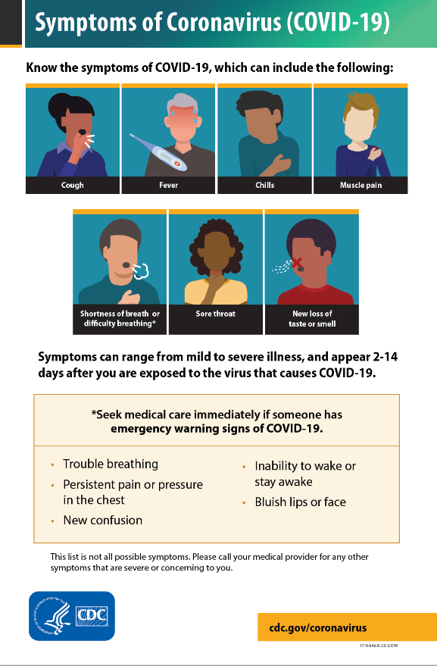
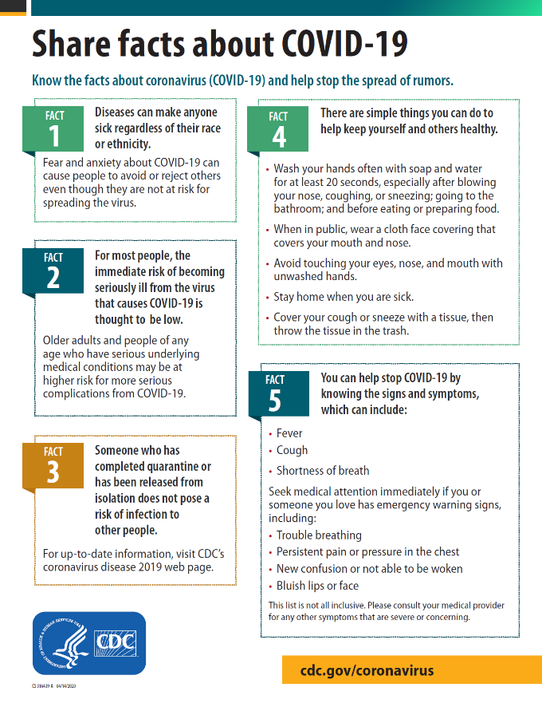

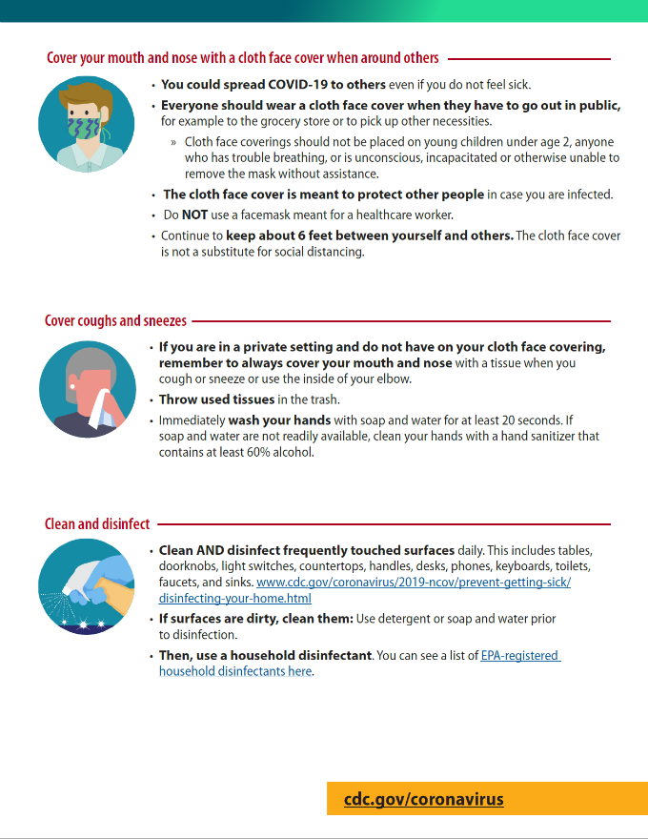
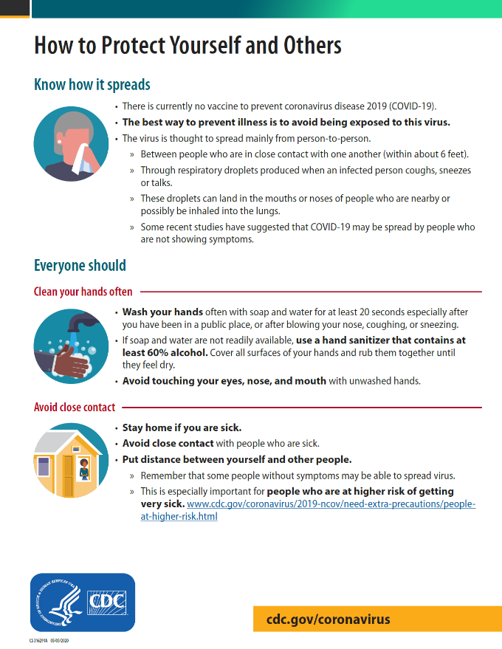

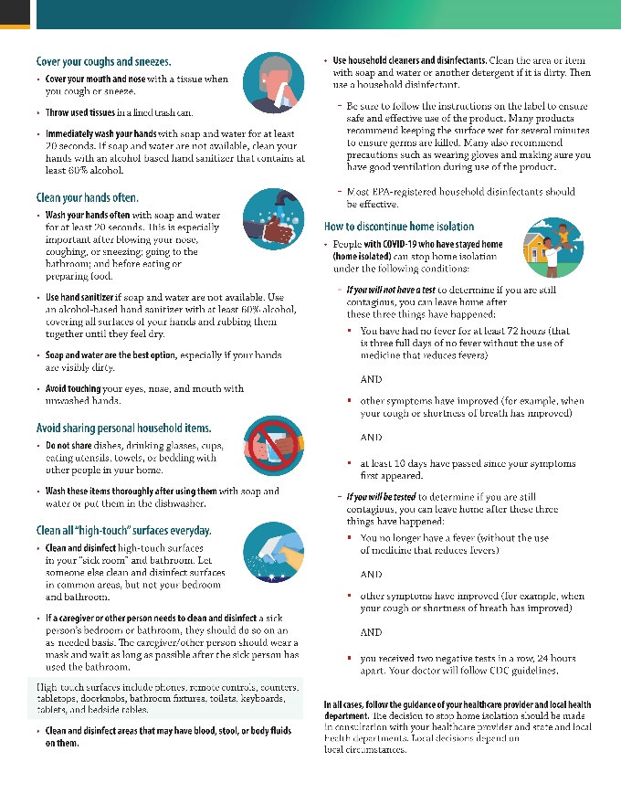
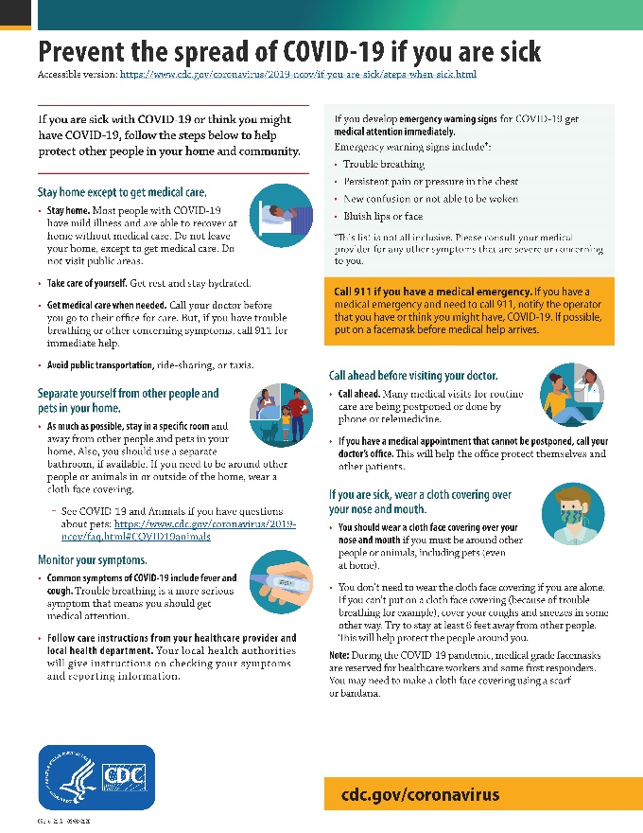

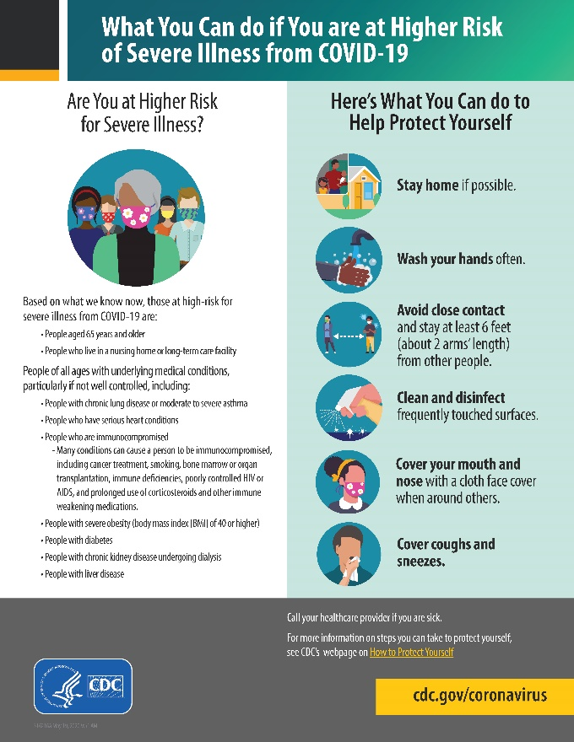
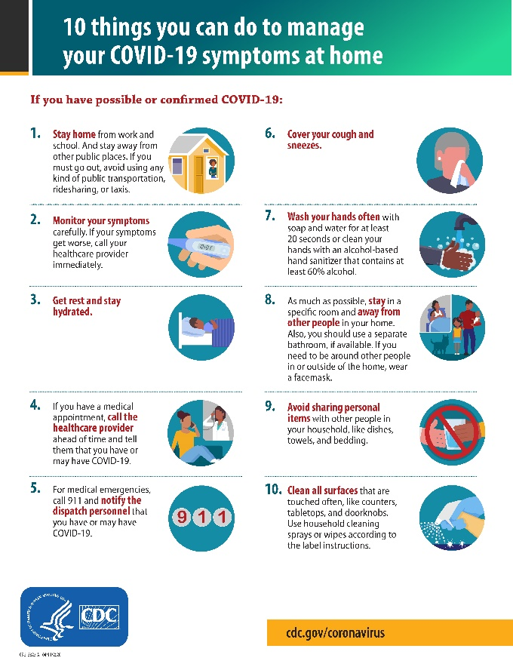

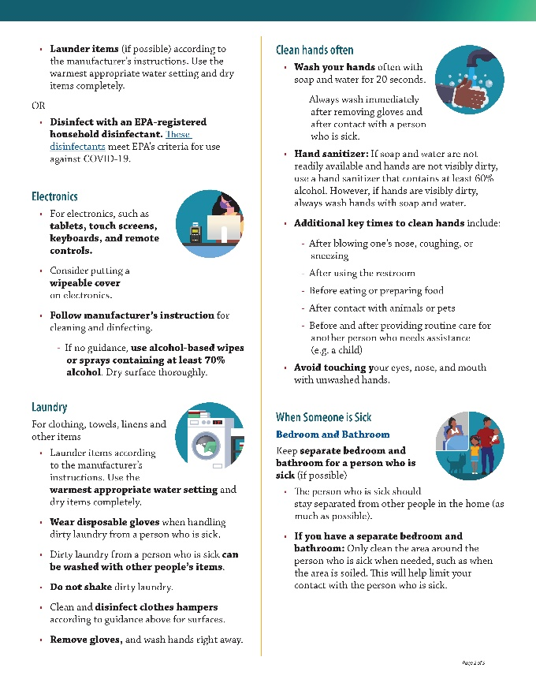
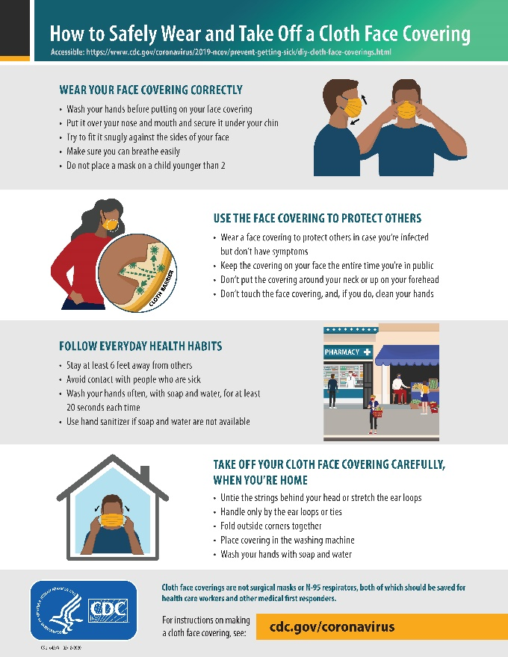
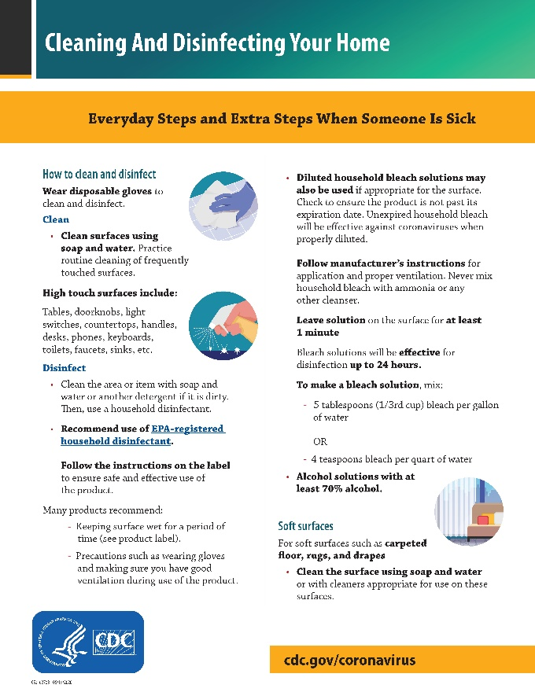
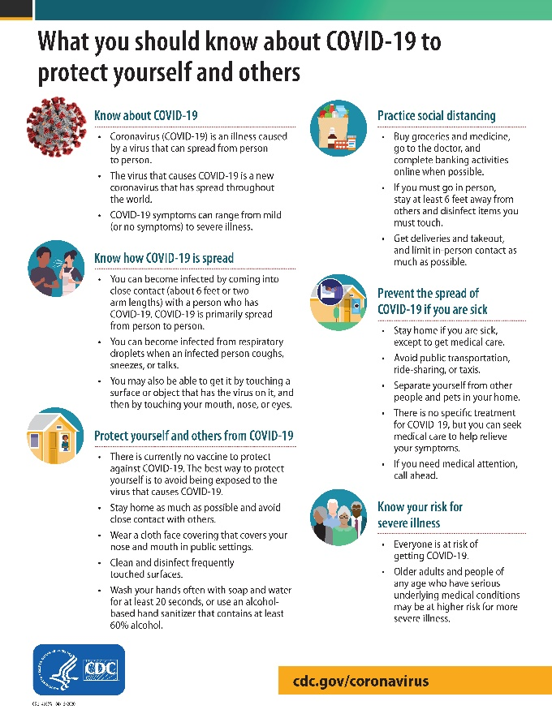

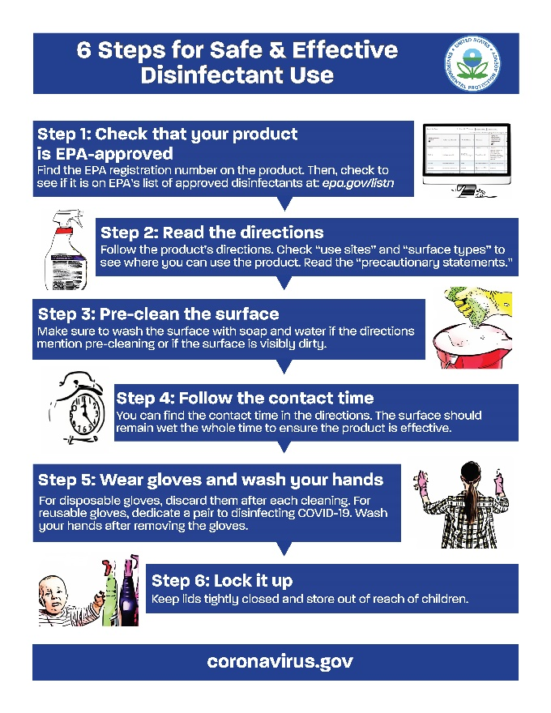
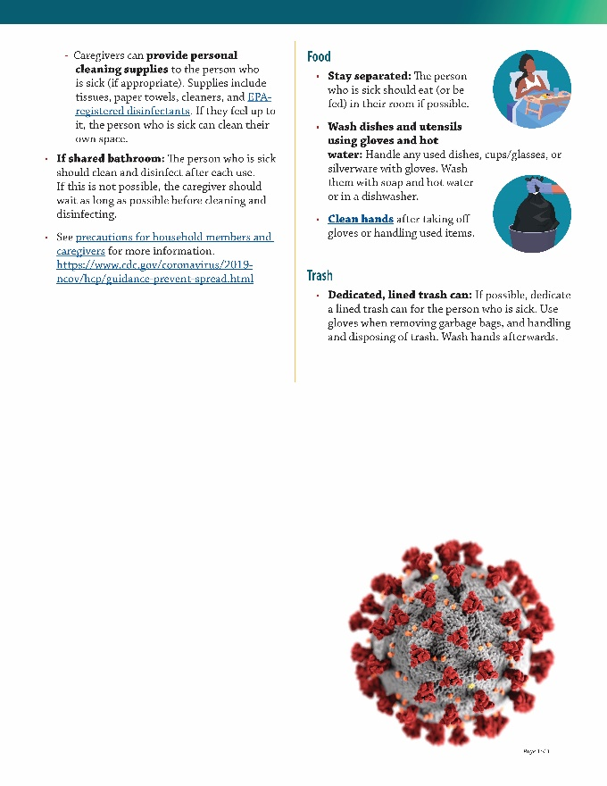

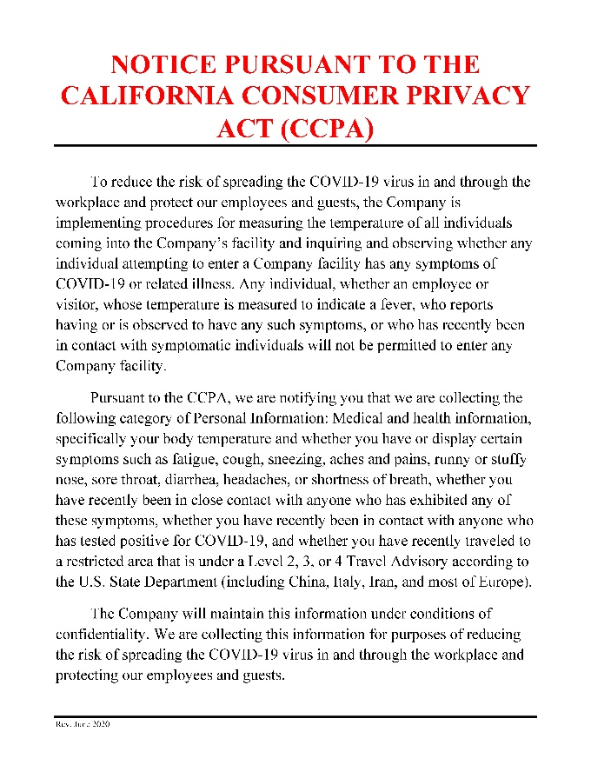
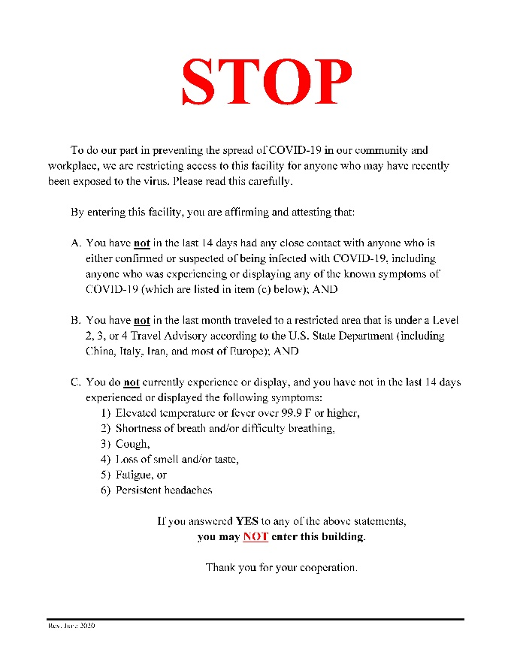

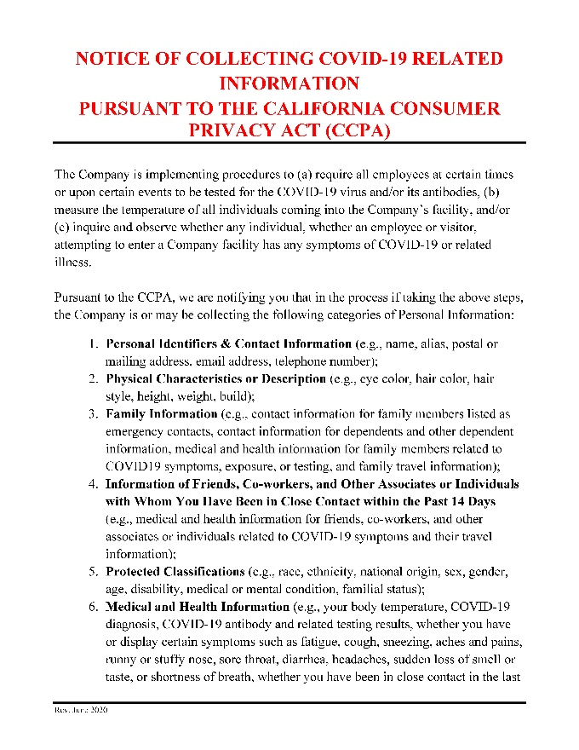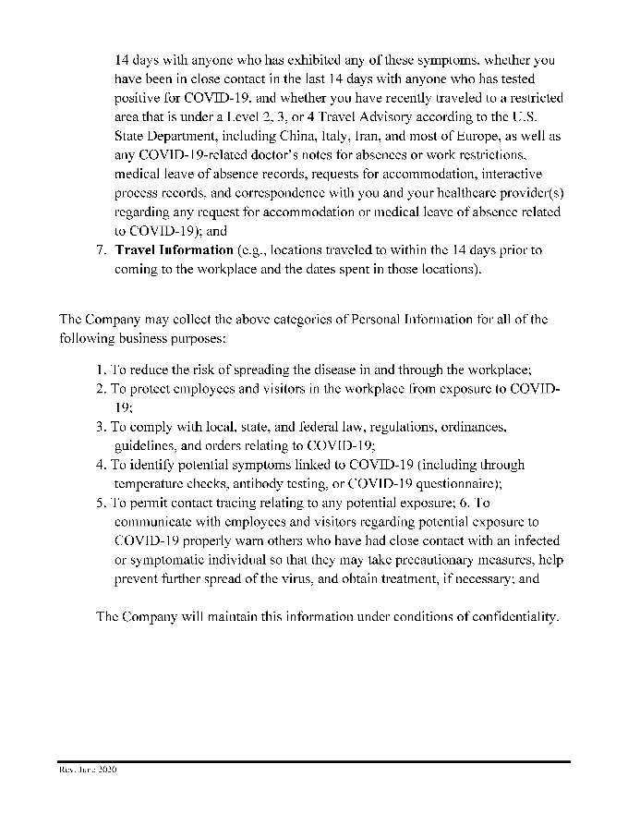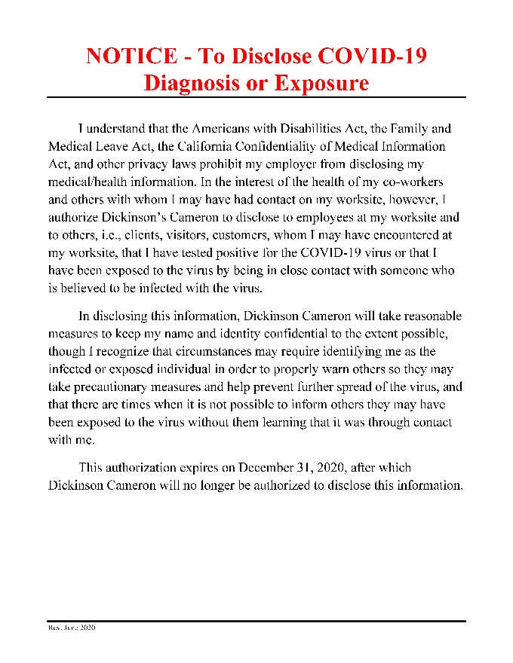

Download posters [here]

June 2020

Dickinson Cameron COVID-19 Best Practices for Jobsites:

As we continue through these unprecedented times, we will all continue following the guideline set by the CDC and government agencies. Below is an enhanced protocol set forth by our company to help combat this issue. This is a minimum and if your respective companies protocols are more stringent then please follow. In addition to the company protocol specified, below we are requesting that you inform your employees they cannot come to our job sites if they have flu type symptoms such as fever, body ache and chest discomfort including coughing. Finally, if an employee was recently in Europe, Iran, China or on a cruise they should not come to our sites within 14 days after the day they arrived in the US, they should follow the CDC self-quarantine protocol. Should you have any questions or concerns please contact me directly, Tom McCollum Dickinson Cameron Corporate Safety Officer, at 619 726-9670

1. Each project site Superintendent is designated as the team member who will oversee the below enhanced protocols and previously published protocols until this notice is superseded.

2. All personnel on site should wash their hands 4 times per day at a minimum. The hand washings with soap and water is always preferred. Use of hand sanitizer is the next preferred. Rubbing alcohol or grain alcohol (3/4 cup) mixed with Aloe Vera (1/4 cup) and a dash of lemon juice will make home made hand sanitizer if the availability of bottled hand sanitizer is low.

3. Social distancing is key to the mitigation of the COVID-19 virus. Morning and mid-day safety talks, stretch and flex gatherings and other safety related activities shall be limited to groups of 10 or less and should be conducted outside, or virtually, if possible. Each employee shall maintain a minimum 6’ foot distance from other employees during such gatherings.

4. In person meetings and gatherings shall be held via conference call or TEAMs whenever possible.

5. All shared social food gatherings (pizza, sandwiches, donuts, bagels, coffee, etc.) are prohibited.

6. All jobsites employees (craft and supervision) need to machine wash their exterior work clothes (Carhart overalls, coveralls, coats, gloves, etc.) at least three times a week.

7. All workers will have their temperature measured with a non-touch scan. If greater than 100 degrees they will not be allowed to enter the site and directed to seek medical attention.

8. All jobsite vehicles and equipment shall have their stepladders, joysticks, steering wheels, cab interior and hand grab safety features washed twice daily with a household disinfectant spray and cloth / paper towel, by the trade responsible for the equipment. All cleaning refuse will be disposed of in a covered waste receptacle.

9. All field office table tops, flat surfaces, keyboards, interior and exterior door knobs/handles and other common touchable surfaces should be cleaned with a disinfectant twice daily by a project staff member. The use of disposable rubber gloves and other appropriate PPE should be used if a staff member elects to perform the cleaning themselves. If gloves unavailable the project staff member shall wash their hands with soap and water after the cleaning activity.

10. All food wrappers, debris and other trash shall be removed from all vehicles and equipment daily at the beginning and end of each shift.

11. Washing stations, if not currently placed next to portable toilets, shall be put in place (as availability warrants) for the duration of the jobsite and shall be serviced daily.

12. Avoid any physical contact with anyone on site including, but not limited to. hand shaking, elbow bumping, knuckle bumping or other similar friendly gestures.

Dickinson Cameron COVID-19 Jobsite Return to Work Protocol:
- Postings will be prominently displayed at entrances and Job Safety Board, detailing COVID Return to work plan and DCC Best Practices.

- All workers will submit to a non-touch digital scan temperature reading.

  - If Scan reports a reading over 100.00 F worker will be told to not enter the facility and advised to seek medical attention.
  - DCC has appointed the project Superintendent as the monitor of who is to supervise Subcontractor monitors whom are responsible for allocation of resources, how PPE is applied, what additional protective equipment may be required, and at what specific distance workers shall be deployed from other workers. Work schedule has been modified to support social distancing.
  - Monitor/ Superintendent will take special care and utilize proper PPE to minimize exposure while taking temperature reading. Monitoring equipment will be managed by the appointed personal only. All devices will be immediately sanitized if it comes into contact with the worker.

- Workers will maintain social distancing protocol, wear masks & avoid working closer than 6 feet.
  - Superintendent/ monitor will provide training on how to properly wear face mask.
  - Working areas will be arranged to not encroach on the social distance minimums.
  - Meetings should continue to be conducted virtually or employees should be distanced at least 6 feet from each other.

- Cleaning and sanitizing protocols
  - Hand washing (soap and Water or hand sanitizer if water unavailable) every entry to the work area for 20 seconds and after sneezing, restroom use, accessing back of house corridors, going on a break or after starting a shift.
  - Shared tools such as cart handles, ladders, rolling scaffolds and aerial lift control and handrail surfaces must be sanitized by subcontractor if used by another worker.
  - Public areas used by DCC and it’s subcontractors, (railings and door handles, barricade door handles, elevator buttons, escalator handrails) must be cleaned once per shift. DCC and our subcontractors will be responsible for the areas we impact, (within the barricade).

- DCC will provide a new mask to its employees weekly. The provided mask should be marked with the user’s initials and used for at least a week before replacement is provided.
  - Subcontractors will furnish their own mask.

